Dell Tablet Open Source Notes
Version 1.4, May 1, 2015
Welcome to the Dell Open source guide. Here you'll find the guide that describes how to build and flash the kernel for Dell Venue10 5050 tablet.

Prerequisite System Setup
- Operating system
Ubuntu 12.04 64bit or higher.
- Setup android build environment.
https://source.android.com/source/initializing.html
- X86 compiler from AOSP source code
This is required in order to compile the kernel for Venue 10 5050.
For the branch to be pulled, “android-5.0.2_r1” is suggested. So to get the compiler from AOSP, you can do this,
repo init -u https://android.googlesource.com/platform/manifest -b android-5.0.2_r1
repo sync prebuilts/gcc/linux-x86/x86/x86_64-linux-android-4.8
For full AOSP code, please refer to the link below, (optional)
https://source.android.com/source/downloading.html

Enable developer mode
- Find the “Build number” section in Settings->About tablet.
- Tap the “Build number” section continually until the message “You are now a developer” pops up. Normally, you need to tap 7 times.
- Enable USB debugging in Settings->Developer options.
- Connect your device to your computer over USB.

Build the kernel image from the kernel sources
- In the following instructions, we assume you have “X86 compiler from AOSP source code” downloaded to “dell_Venue10_5050”. This could also be the root directory of Android source.
- Download kernel source package “dell_venue10_5050_kernel.0501.tgz”.
- Extract the kernel source package “dell_venue10_5050_kernel.0501.tgz” in dell_Venue10_5050
$ tar -xzvf dell_venue10_5050_kernel.0501.tgz
- Once done, you should be able to see the “linux” directory, adb, kernel_build.sh, Makefile, diffconfig, in dell_Venue10_5050.
- Run the kernel build script, kernel_build.sh.
$ ./kernel_build.sh
- Kernel image “boot.img” will be created in out.

Flash boot image
- Download image package “Venue10_5050_droidboot_opensource.tgz”.
- Extract the package in dell_Venue10_5050
$ tar -xzvf Venue10_5050_droidboot_opensource.tgz
- Copy the previous built boot.img to the folder, Venue10_5050_droidboot_opensource.
cp out/boot.img Venue10_5050_droidboot_opensource
- Enter the folder “Venue10_5050_droidboot_opensource”. Then run the script boot_droidboot.sh to enter Fastboot mode. Once the script, boot_droidboot.sh, is executed, “secure boot” will be disabled, and warranty will be voided.
$ cd Venue10_5050_droidboot_opensource
$ ./ boot_droidboot.sh
- If the tablet enters Fastboot mode correctly, you will see the screen like below.
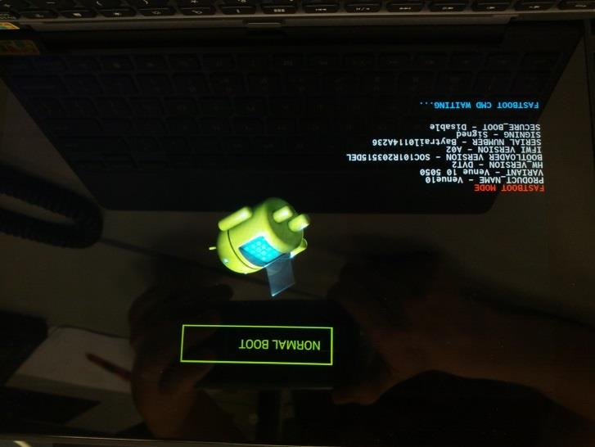
- Run these flash commands:
$ fastboot flash boot boot.img
$ fastboot reboot
- Now the kernel is built, and boot.img is flashed to your device.

